**Overview of SATUSEHAT**

Updated 30 June 2023

Written by Merlin Wijaya and Sneha Kumar

Based on:

SATUSEHAT Playbook Resume Medis Rawat Jalan (Outpatient)

Rev 5.0c 14 December 2022

Contents

Introduction 2

End-to-End Flow 3

A. Onboarding 3

1. Sign up to SATUSEHAT 3

2. Authenticate to SATUSEHAT 4

3. Register the Organizational Structure 5

4. Register the Location Structure 5

5. Store the IHS Number for Health Workers 5

B. Daily Business 6

1. Master Data 6

2. Transactional Data 6

3. Patient Consent 8

4. Data Translation 9

Appendix 12

A. Endpoint Information 12

B. Postman Collection 12

C. The outpatient medical resume data or variables that are exchanged 12

D. POSTMAN Transactions Translations 15

# Introduction

SATUSEHAT is a health data exchange platform (HIE: health information exchange) that connects information systems and applications from all members of the Indonesian digital health ecosystem which includes hospitals, health care providers, regulators, guarantors, and digital service providers.

Current condition of Indonesia:

* Over 400 government-owned applications that have not yet been integrated, leading to inefficiencies and redundancies.
* Multiple applications collect similar data, resulting in data duplication and fragmentation.
* The developer application has not been integrated with the health services ecosystem of Indonesia, limiting seamless information exchange.
* Variances in metadata standards create challenges for interoperability, hindering smooth data integration.
* Lack of a standardized format for interoperability leads to inconsistent application-to-application integration.

Goals of SATUSEHAT:

* Establish specifications and mechanisms for business processes, data management, technology, and safety.
* Enable software developers to utilize any programming language for application development, utilizing HL7 and HTTPS REST API.
* Have a unique SATUSEHAT number as a single identifier for each patient, ensuring all health services can access this information.

IRIS is meant to act as the “middleman” by establishing communication between the hospital EMR and SATUSEHAT. The data pipeline to be established is as follows:

1. IRIS requests data (xls, etc.) from EMR of health care providers through RESTful API.
2. The data is transformed (DTL) by mapping the EMR data to FHIR standards. This data is also persistent in IRIS and to be utilized for analytics in the future.
3. The FHIR data is sent to SATUSEHAT.

This document provides a brief explanation of the end-to-end flow for each hospital to perform data exchange on SATUSEHAT for outpatient.

# End-to-End Flow

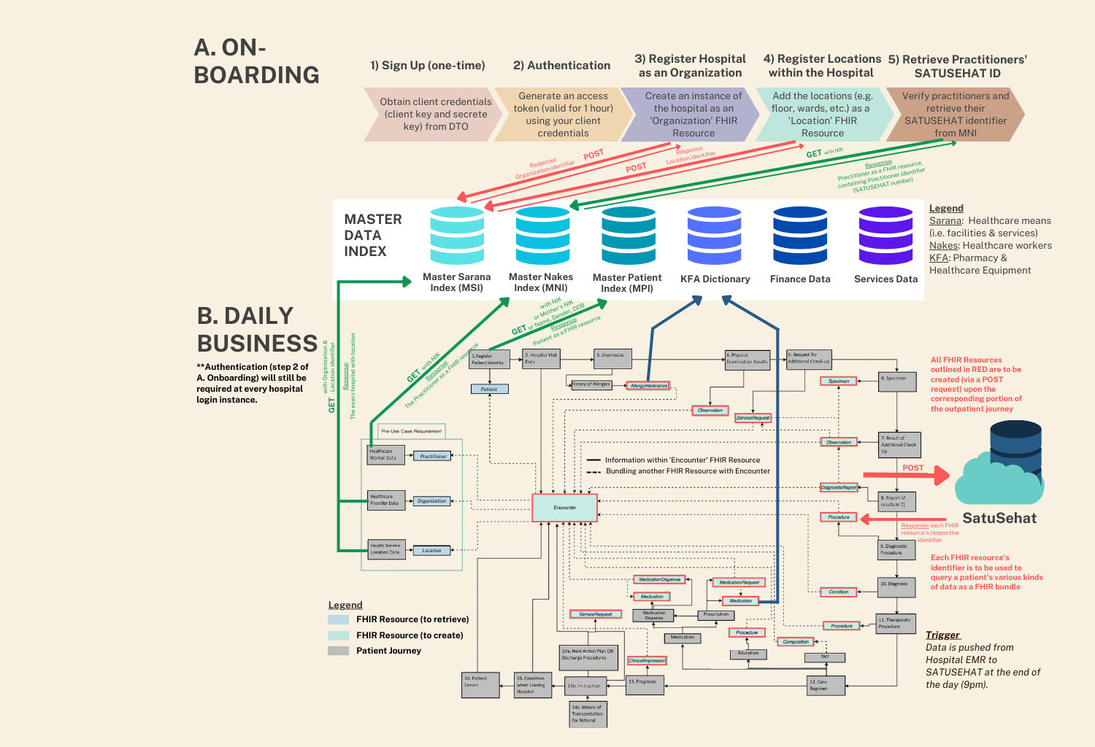

*Figure 1: Hospital End-to-End Flow*

As shown in Figure 1, the entire flow can be split into two major portions: A. Onboarding, where the healthcare entity is signed up and set up on the SATUSEHAT platform, and B. Daily Business, where the healthcare entity exchanges patient data from their daily patient visits via various API requests.

## Onboarding

Before being able to exchange data on SATUSEHAT, there are 5 steps that each healthcare entity needs to complete as a pre-use case requirement:

### Sign up to SATUSEHAT

Each healthcare entity starts with a one-time sign-up process. It may obtain it’s unique API key, consisting of the client key (or client ID) and secret key (or client secret), from MOH Indonesia’s Data Transformation Office (DTO). The requester must send an email with the subject [Request for Client ID and client secret] to ihs@dto.kemkes.go.id in the following format:

1. Name
2. Email
3. Institution Name

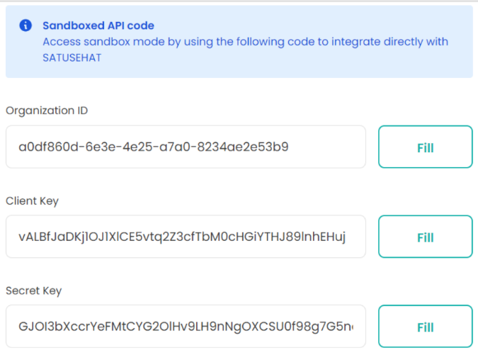An example is shown below. Take note of the client key and client secret; these are to be used as client login credentials in future to perform data exchange on SATUSEHAT in part B.

*Figure 2: Sample API Key*

### Authenticate to SATUSEHAT

SATUSEHAT uses the standard OAuth2 protocol to authenticate users with the grant type of `client credentials` (i.e. the client key and secret key obtained in the previous step).

When a POST request is performed using the OAuth base url (see Appendix A) with the client ID and secret in the body, it responds with an access token of type `Bearer`. This token is valid for 1 hour and allows the hospital user to perform data exchange on SATUSEHAT during its period of validity.

|  |  |
| --- | --- |
| **Method** | POST |
| **Target URL** | {{oauth_base_url}}/accesstoken?grant_type=client_credentials |
| **Header** | Content-Type: application/x-www-form-urlencoded |
| **Body** | client_id: <client_id_from_step1>  client_secret: <client_secret_from_step1> |

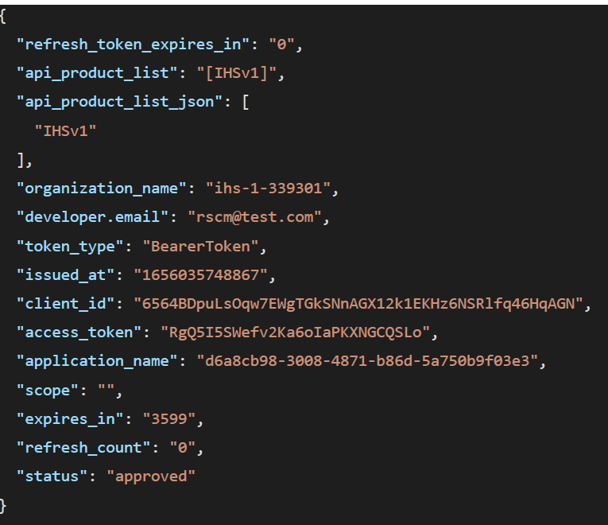An example of a response is shown below:

Take note of the `access_token`, the token used for performing data exchange.

For all subsequent data exchange (API requests): use Bearer <access_token> for authorization.

### Register the Organizational Structure

To integrate to SATUSEHAT, each healthcare entity also needs by submitting data related to the organizational structure available within the entity (referred to as sub-organizations). Entities that are included in the category of health service facilities (referred to as parent organizations), will receive a SATUSEHAT number from the MoH upon registration. The parent organization will then send the existing organizational/sub-organizational structure within the institution. Each sub-organization under the main organization needs to send data to SATUSEHAT.

Sub-organizational data is sent using Organization resources via a POST request. Resource Organization is used to record data on a group of people or organizations with the same purpose. This is indicated by the management structure of the organization. The organization filling template can be accessed at the following link: [Organization & Location Registration Template](https://docs.google.com/spreadsheets/d/1JBP2aUtPqCrsIyVvr2Mus1DMeLTumBn9a0azIHyv4f4/edit#gid=1571590515)

### Register the Location Structure

The location structure is a physical location which can be a building, a room where health services are carried out. Institutions that will integrate into SATUSEHAT need to register or send data related to the location structure available within the institution. Site structure data refers to detail and position information for the physical places where services are provided and resources and participants can be stored, located, hosted, or accommodated. Structural data is sent using the Location resource via a POST request.

The organizations and locations are all stored in the Master Sarana Index (see B. Daily Business, a. Master Data for more details).

### Store the IHS Number for Health Workers

To register data for health workers, SATUSEHAT ID information is required from the health workers concerned. Information regarding a worker’s SATUSEHAT ID can be obtained from the Master Nakes Index (MNI). MNI stores data on health workers from all sources that officially publish lists of health workers. SATUSEHAT ID can be stored in each internal system of health facilities and partners other than health facilities. SATUSEHAT ID will make it easier to report health services related to health workers.

## Daily Business

### Master Data

The Master Data Index is a standardized data dictionary that consists of:

* Patient Data ([Master Patient Index](https://docs.google.com/spreadsheets/d/1i4fdeq4XxbGjBURbYpMIQGDQ09jkTELd/edit#gid=1900046778))
  + The data contains demographic details of every citizen in Indonesia
  + This data is governed and maintained by Dukcapil (government body that manages citizenship status).
* Health Workers [Nakes] Data ([Master Nakes Index](https://docs.google.com/spreadsheets/d/1i4fdeq4XxbGjBURbYpMIQGDQ09jkTELd/edit#gid=1900046778))
  + The data is sourced from the SISDMK data, which contains information such as healthcare worker’s name, registration letter, healthcare practice license, etc.
* Healthcare Facilities & Services [Fasyankes] Data (Master Sarana Index)
  + Data to includes 35 different types of healthcare services facilities available.
  + Data based on SISDML, SIRS, and SIMADA.
* Pharmacy and Medical Devices Data ([KFA Dictionary](https://dto.kemkes.go.id/master-data))
* A standardized dictionary for Pharmacy, Drugs, and Equipment source data from BPOM and LKPP; to have a standardized reference for drugs (e.g. composition, size, volume, etc.). Kfa Dictionary provided by SatuSehat is available in this [drive.](https://docs.google.com/spreadsheets/d/1fXkAeVnYN6lb3wq2eEC-hURlCPQzYqGa/edit#gid=1302218164)
* Financing Data
* All healthcare facilities use the Master Financing data to standardize the costs for the health services, etc.
* Service Data
* All healthcare facilities use the Master Service Data to have standardized reference codes for the different types of health services

### Transactional Data

SATUSEHAT currently has [32 FHIR profiles](https://simplifier.net/guide/SATUSEHAT-FHIR-R4-Implementation-Guide/Home/FHIRProfiles?version=current) some of which have with extensions for some on SATUSEHAT. Each profile defines the ID Core and extensions for related resources. Each resources have different numbers and types of data element.

For example, at the time of patient visit registration, the following elements must be submitted:

1. Encounter.status
2. Encounter.statusHistory
3. Encounter.class
4. Encounter.subject
5. Encounter.period.start
6. Encounter.location
7. Encounter.serviceProvider

Other mandatory elements can be sent after the visit ends. An example of the Encounter resource that is required is shown below, where M refers to mandatory and O refers to optional.

|  |  |  |
| --- | --- | --- |
| [Resource Encounter](http://hl7.org/fhir/R4/encounter.html) | | |
| **Element Data / Path** | **Mandatory Type** | **Description** |
| Encounter.identifier | O | Health facility internal ID for this visit. This is an official ID issued by the health facility to mark patient visits. |
| Encounter.status | M | Stage status of the patient encounter |
| Encounter.statusHistory | M | Store history of patient visits' status |
| Encounter.class | M | Classification of patient encounters |
| Encounter.classHistory | O | Store classification history of patient visits |
| Encounter.type | O | [Specific type of visit](https://simplifier.net/packages/hl7.fhir.r4.core/4.0.1/files/80297) |
| Encounter.serviceType | O | Specific type of service provided |
| Encounter.priority | O | [Indication of the urgency of the visit](https://simplifier.net/packages/hl7.fhir.r4.core/4.0.1/files/79332) |
| Encounter.subject | M | Subject of the patient meeting |
| Encounter.episodeOfCare | O | Information on the episode of care performed at this visit. Refer to EpisodeOfCare resources |
| Encounter.basedOn | O | Request underlying this visit (ex: referral request). Referring to a ServiceRequest resource |
| Encounter.participant | M | Patient encounter participant |
| Encounter.period | M | Time for encounter from arrived to finished |
| Encounter.length | O | [Number of times the visit occurred](http://hl7.org/fhir/R4/datatypes.html#Duration) |
| Encounter.reasonCode | O | [Code for the reason for the visit](http://hl7.org/fhir/R4/valueset-encounter-reason.html) |
| Encounter.reasonReference | O | Reasons for the visit. Can refer to Condition / Procedure / Observations / Immunization Recommendation resources |
| Encounter.diagnosis | M | Diagnosis can be early diagnosis and/or discharge. Diagnosis can be filled according to the "Condition" resource of the patient. "Condition" in the diagnosis can be recorded more than 1 |
| Encounter.account | O | Account used for billing. Can refer to Account resource |
| Encounter.hospitalization.  preAdmissionIdentifier | O | [Identifier for pre-admission](http://hl7.org/fhir/R4/datatypes.html#Identifier) |
| Encounter.hospitalization.origin | O | Location or organization of origin of the patient prior to admission. Can refer to Location or Organization resource |
| Encounter.hospitalization.admitSource | O | [Patient admission origin](https://simplifier.net/packages/hl7.fhir.r4.core/4.0.1/files/80984) |
| Encounter.hospitalization.reAdmission | O | [The type of readmission that occurred (if any). If this element is empty, then the visit is not considered as a readmission](https://simplifier.net/packages/hl7.fhir.r4.core/4.0.1/files/81712) |
| Encounter.hospitalization.dietPreference | O | [Dietary preferences reported by patients](https://simplifier.net/packages/hl7.fhir.r4.core/4.0.1/files/81748) |
| Encounter.hospitalization.specialArrangement | O | [Special requests made for the inpatient visits such as provision of special equipment etc](https://simplifier.net/packages/hl7.fhir.r4.core/4.0.1/files/80150) |
| Encounter.hospitalization.destination | O | The location/organization from which the patient was discharged. Refer to Location or Organization resource |
| Encounter.hospitalization.dischargeDisposition | M | [Category or type of location after the patient is discharged](http://hl7.org/fhir/R4/valueset-encounter-discharge-disposition.html) |
| Encounter.location | M | The location of the patient encounter |
| Encounter.serviceProvider | M | Information on the organization responsible for the visit. Reference the parent Organization resource |
| Encounter.partOf | O | Visits of which this visit is a part (administratively or in time). Can refer to Encounter resources |

### [Patient Consent](https://satusehat-kemkes-go-id.translate.goog/platform/docs/id/api-catalogue/consent/?_x_tr_sl=id&_x_tr_tl=en&_x_tr_hl=en)

The Consent resource is to inform or seek approval/permission from the relevant data owner (patient) so that it is allowed to be accessed by other parties (organizations) who are also legally registered and have access to the SATUSEHAT ecosystem.

Each patient needs to OPTIN/OPTOUT the Consent for each organization. If a patient opts out, there is no Consent that the organization. However, if a patient opts in, the organization must POST a Consent with the following payload.

{

    "patient_id": "P02478375538",

    "action": "OPTIN",

    "agent": "handoko"

}

Note that each organization may only POST Consent requests for their respective organization, as shown in the response below:

When a patient OPTOUT, the organization still can POST encounter and GET encounter by resource ID. When a patient OPTIN, the organization can GET encounter by subject (patient SATUSEHAT ID) and GET patient by resource ID or NIK, Name, and Birthdate.

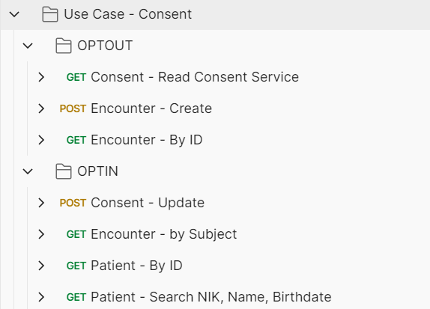

### Data Translation

1. [ICD-9-CM](https://www.cdc.gov/nchs/icd/icd9cm.htm) standard for naming medical procedures and treatments.

* Used in Procedure resource.
* Example for Procedure.code:

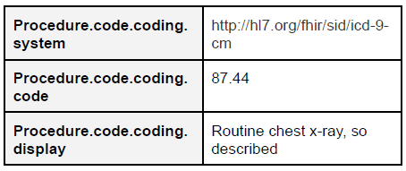

1. [ICD-10 version 2010](https://icd.who.int/browse10/2010/en) for diagnostic standard or disease classification.

* Used in Service, Medication, Procedure, Condition, and ClinicalImpression resources.
* Example for Procedure.reasonCode:

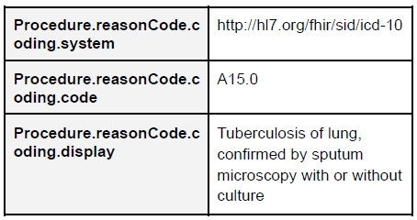

1. SNOMED-CT clinical terms standard.

* Used in [AllergyIntolerance](https://docs.google.com/spreadsheets/d/1tN9lFaK2GJ3itObaMOQds8JkI8rjQE2tacYRRSNgPF8/edit#gid=0), Specimen, and Procedure resources.
* Specimen.type code are listed under lampiran 5 in the playbook.
* Specimen.collection.method code are listed under lampiran 6.6 in the playbook.
* Procedure.statusReason: <http://hl7.org/fhir/valueset-procedure-not-performed-reason.html>
* Procedure.followUp: <http://hl7.org/fhir/R4/valueset-procedure-followup.html>
* Example for AllergyIntolerance:

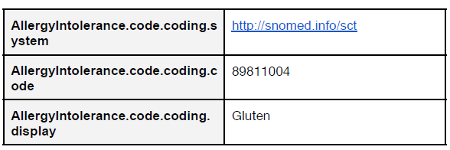

1. LOINC terminology standard for health measurements, observations, and documents.

* Used in Observation, ServiceRequest, DiagnosticReport, and Composition resources.
* Reference for laboratory examination mapping with LOINC code can be seen thro ugh the following link: <https://dto.kemkes.go.id/terminology/loinc>
* For examination parameters under the category “Request” or “Demand & Results”, use from [the Laboratory Terminology file](https://dto.kemkes.go.id/export-loinc).
* Example for ServiceRequest:

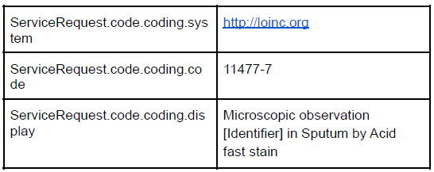

#### Sending data to SATUSEHAT

In sending data through the FHIR API, the resources sent may be sent simultaneously at once (Immunization Use Case). To send more than one resource in one submission, the "Bundle" resource must be used.

The main framework of the “Bundle” resource can be seen in the following example:

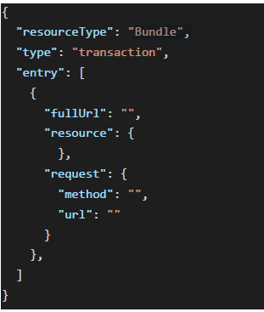

#### Error Response

Below are listed error responses that user may get when sending a request through POSTMAN. The example of each error are available in the [SATUSEHAT PUBLIC](https://www.postman.com/satusehat/workspace/satusehat-public/overview) under 01. SATUSEHAT – Resource Example.

Success status:

* 200 – OK (when performing a GET or PUT)
* 201 – Created (when performing a POST)

Error 20x:

* Error 200 – Consent Error

Error 40x

* Error 400 – Path URL and Payload ID do not match
* Error 400 – Not OPTIN yet
* Error 400 – Error JSON
* Error 401 – Error no API role
* Error 401 – No Product Match (Unauthorized KMS API / wrong environment)
* Error 401 – Invalid ClientID
* Error 401 – Invalid Token
* Error 403 – Forbidden
* Error 404 – Wrong URL

Error 50x

* Error 503 – API error

# Appendix

### Endpoint Information

Development Endpoint

|  |  |
| --- | --- |
| **OAuth Base URLs** | [https://api-SATUSEHAT-dev.dto.kemkes.go.id/oauth2/v1](https://translate.google.com/website?sl=id&tl=en&hl=en&u=https://api-satusehat-dev.dto.kemkes.go.id/oauth2/v1) |
| **Base URL** | [https://api-SATUSEHAT-dev.dto.kemkes.go.id/fhir-r4/v1](https://translate.google.com/website?sl=id&tl=en&hl=en&u=https://api-satusehat-dev.dto.kemkes.go.id/fhir-r4/v1) |
| **Consent URL** | [https://api-SATUSEHAT-dev.dto.kemkes.go.id/consent/v1](https://translate.google.com/website?sl=id&tl=en&hl=en&u=https://api-satusehat-dev.dto.kemkes.go.id/consent/v1) |

Staging Endpoint

|  |  |
| --- | --- |
| **OAuth Base URLs** | [https://api-SATUSEHAT-stg.dto.kemkes.go.id/oauth2/v1](https://translate.google.com/website?sl=id&tl=en&hl=en&u=https://api-satusehat-stg.dto.kemkes.go.id/oauth2/v1) |
| **Base URL** | [https://api-SATUSEHAT-stg.dto.kemkes.go.id/fhir-r4/v1](https://translate.google.com/website?sl=id&tl=en&hl=en&u=https://api-satusehat-stg.dto.kemkes.go.id/fhir-r4/v1) |
| **Consent URL** | [https://api-SATUSEHAT-stg.dto.kemkes.go.id/consent/v1](https://translate.google.com/website?sl=id&tl=en&hl=en&u=https://api-satusehat-stg.dto.kemkes.go.id/consent/v1) |

Production Endpoint

|  |  |
| --- | --- |
| **OAuth Base URLs** | [https://api-SATUSEHAT.kemkes.go.id/oauth2/v1](https://translate.google.com/website?sl=id&tl=en&hl=en&u=https://api-satusehat.kemkes.go.id/oauth2/v1) |
| **Base URL** | [https://api-SATUSEHAT.kemkes.go.id/fhir-r4/v1](https://translate.google.com/website?sl=id&tl=en&hl=en&u=https://api-satusehat.kemkes.go.id/fhir-r4/v1) |
| **Consent URL** | [https://api-SATUSEHAT.dto.kemkes.go.id/consent/v1](https://translate.google.com/website?sl=id&tl=en&hl=en&u=https://api-satusehat.dto.kemkes.go.id/consent/v1) |

### Postman Collection

Import collection via: <https://s.id/CollectionSATUSEHAT>

Fork workspace via: <https://s.id/PostmanSATUSEHAT>

### The outpatient medical resume data or variables that are exchanged

|  |  |  |  |  |
| --- | --- | --- | --- | --- |
| **No** | **Variable** | | **Resource FHIR** | **Path FHIR** |
| 1 | General Identity of the Patient | |  |  |
| a | SATUSEHAT Number | Patient | , |
| Patient.identifier.system |
| Patient.identifier.value |
| b | Full Name | Patient | Patient.name.text |
| c | Resident Identification Number (NIK) | Patient | Patient.identifier.use |
| Patient.identifier.system |
| Patient.identifier.value |
| d | Other Identity Number (**For Foreigners Only**): Passport / KITAS Number | Patient | Patient.identifier.use |
| Patient.identifier.system |
| Patient.identifier.value |
| e | Place of birth | Patient | Patient.extension:birthPlace |
| f | Date of birth | Patient | Patient.birthDate |
| g | Gender | Patient | Patient.gender |
| h | Guarantor Name | Patient | Patient.contact.name.text |
| i | Guarantor Phone Number | Patient | Patient.contact.telecom.system |
| Patient.contact.telecom.value |
| Patient.contact.telecom.use |
| j | Room / Class / Poly | Encounter | Encounter.location |
| k | Name of Doctor in Charge of Services (DPJP) | Encounter | Encounter.participant |
| 2 | Entry Date and Time | |  |  |
| a | Date of entry | Encounter | Encounter.period.start |
| b | Time of entry | Encounter | Encounter.period.start |
| 3 | Administrative Discharge Date and Time | |  |  |
| a | Administrative Discharge Date | Encounter | Encounter.period.end |
| b | Administrative Discharge Time | Encounter | Encounter.period.end |
| 4 | Diagnosis | |  |  |
| a | Early Diagnosis/Admission | Encounter | Encounter.diagnosis.condition |
| Encounter.diagnosis.use |
| Condition | Condition.code |
| b | Final Diagnosis / Exit |  |  |
| 1) Primary Diagnosis | Encounter | Encounter.diagnosis.condition |
| Encounter.diagnosis.use |
| Encounter.diagnosis.rank |
| Condition | Condition.code |
| 2) Secondary Diagnosis | Encounter | Encounter.diagnosis.condition |
| Encounter.diagnosis.use |
| Encounter.diagnosis.rank |
| Condition | Condition.code |
| 5 | Supporting investigation | |  |  |
| a | Laboratorium | Observation | Observation.category.coding |
| Observation.code.coding |
| Observation.value[x] |
| 6 | Actions / Medical Procedures | | Procedure | Procedure.code.coding |
| Procedure.category.coding |
| 7 | Drugs / Therapies | |  |  |
| a | Drug Name | Medication | Medication.code |
| MedicationRequest | MedicationRequest.medicationReference |
| b | Form / Preparation | Medication | Medication.form |
| MedicationRequest | MedicationRequest.medicationReference |
| c | Drug Amount | MedicationRequest | MedicationRequest.dispenseRequest.quantity |
| d | Method / Route of Administration | MedicationRequest | MedicationRequest.dosageInstruction.route |
| e | Drug Dosage Administered | MedicationRequest | MedicationRequest.dosageInstruction.doseAndRate.doseQuantity.value |
| f | Units | MedicationRequest | MedicationRequest.dosageInstruction.doseAndRate.doseQuantity.unit |
| g | Frequency / Interval | MedicationRequest | MedicationRequest.dosageInstruction.timing |
| h | Additional Rules | MedicationRequest | MedicationRequest.dosageInstruction.additionalInstruction.coding |
| MedicationRequest.dosageInstruction.additionalInstruction.text |
| 8 | Diet | | Composition | Composition.type |
| Composition.section.code.coding |
| Composition.text.status |
| Composition.text.div |
| 9 | Allergy | | AllergyIntolerance | AllergyIntolerance.category.coding |
| AllergyIntolerance.code.coding |
| 10 | Prognosis | | ClinicalImpression | ClinicalImpression.prognosisCodeableConcept.coding |
| 11 | Conditions When Leaving the Hospital | | Condition | Condition.code |
| Encounter | Encounter.hospitalization.dischargeDisposition |
| 12 | Level of Consciousness | | Observation | Observation.category.coding |
| Observation.code.coding |
| Observation.valueCodeableConcept.coding |
| 13 | General state | |  |  |
| a | Vital Signs |  |  |
| 1) Heart Rate | Observation | Observation.category.coding |
| Observation.code.coding |
| Observation.valueQuantity |
| 2) Respiratory | Observation | Observation.category.coding |
| Observation.code.coding |
| Observation.valueQuantity |
| 3) Blood pressure |  |  |
| *Sistole | Observation | Observation.category.coding |
| Observation.code.coding |
| Observation.valueQuantity |
| *Distole | Observation | Observation.category.coding |
| Observation.code.coding |
| Observation.valueQuantity |
| 4) Body temperature | Observation | Observation.category.coding |
| Observation.code.coding |
| Observation.valueQuantity |
| 14 | Patient Discharge Planning | | Encounter | Encounter.hospitalization.dischargeDisposition |
| ServiceRequest | ServiceRequest.code.coding |
| 15 | Prescription | |  |  |
| a | Drug Name | Medication | Medication.code |
| MedicationDispense | MedicationDispense.medicationReference |
| b | Form / Preparation | Medication | Medication.form |
| MedicationDispense | MedicationDispense.medicationReference |
| c | Drug Amount | MedicationDispense | MedicationDispense.quantity |
| d | Method / Route of Administration | MedicationDispense | MedicationDispense.dosageInstruction.route |
| e | Drug Dosage Administered | MedicationDispense | MedicationDispense.dosageInstruction.doseAndRate.doseQuantity.value |
| f | Units | MedicationDispense | MedicationDispense.dosageInstruction.doseAndRate.doseQuantity.unit |
| g | Frequency / Interval | MedicationDispense | MedicationDispense.dosageInstruction.timing |
| h | Additional Rules | MedicationDispense | MedicationDispense.dosageInstruction.additionalInstruction.coding |
| MedicationDispense.dosageInstruction.additionalInstruction.text |
| 16 | Instructions for Follow Up | |  |  |
| a | Control to | ServiceRequest | ServiceRequest.performer.organization ServiceRequest.performer.locationReference ServiceRequest.performer.locationCode |
| b | Date | ServiceRequest.occurenceDateTime |
| c | In an Emergency, call | ServiceRequest.patientInstruction |
| 17 | Education | | Procedure | Procedure.code.coding |
| 18 | Means of Transportation For Referrals | | ServiceRequest | ServiceRequest.locationCode |
| 19 | Patient / Person in Charge (Name and Signature) | | Encounter | Encounter.subject |
| 20 | Doctor in Charge of Services (Name and Signature) | | Encounter | Encounter.participant Encounter.participant.type |

### POSTMAN Transactions Translations

[Link](https://www.postman.com/crimson-meadow-996769/workspace/satusehat-public)

